UNIVERSAL SHIFT REGİSTER

GITHUB LİNKS:

1-https://github.com/aslihan09
2-https://github.com/neva4434
3-https://github.com/Betul006
4- https://github.com/ravzakoc8
5- https://github.com/rumeysa-cyber
6-https://github.com/Seherkaya00

Student Name and Surname | Student ID | Signature
Aslıhan Tanyeli | 24040102029
Ayşe Neva Ağca | 23040102041
Betül Alkan | 23040102069
Ravza Koç | 24040102023
Rümeysa Satılmış | 23040102017
Seher Kaya | 23040102021

1. INTRODUCTION

Shift registers are basic components used for data storage and transfer in digital electronics. In this project, we designed a 4 bit shift register using Verilog HDL. Our main goal was to understand how sequential circuits work and to build a functional hardware component. The system can perform hold, right shift, left shift, and parallel load operations based on a clock signal.

The objective of this project is to understand sequential circuit design and to implement a functional hardware component that can manipulate binary data efficiently.

2. DIGITAL DESIGN

Our design is a 4 bit shift register that uses four flip-flops to store data. A 2 bit input called "process" controls what the system does.
The system is generally synchronous, meaning regular operations (shift, load, hold) happen at the positive edge of the clock signal. However, the reset signal is asynchronous. When reset becomes active (1), the output is cleared immediately without waiting for the clock.

Operation modes:

* Hold (00): Keeps the current value unchanged
* Right Shift (01): Shifts all bits to the right and inserts a new bit from serial input
* Left Shift (10): Shifts all bits to the left and inserts a new bit from serial input
* Parallel Load (11): Loads a 4 bit value into the register simultaneously

The block diagram of the system is shown below.

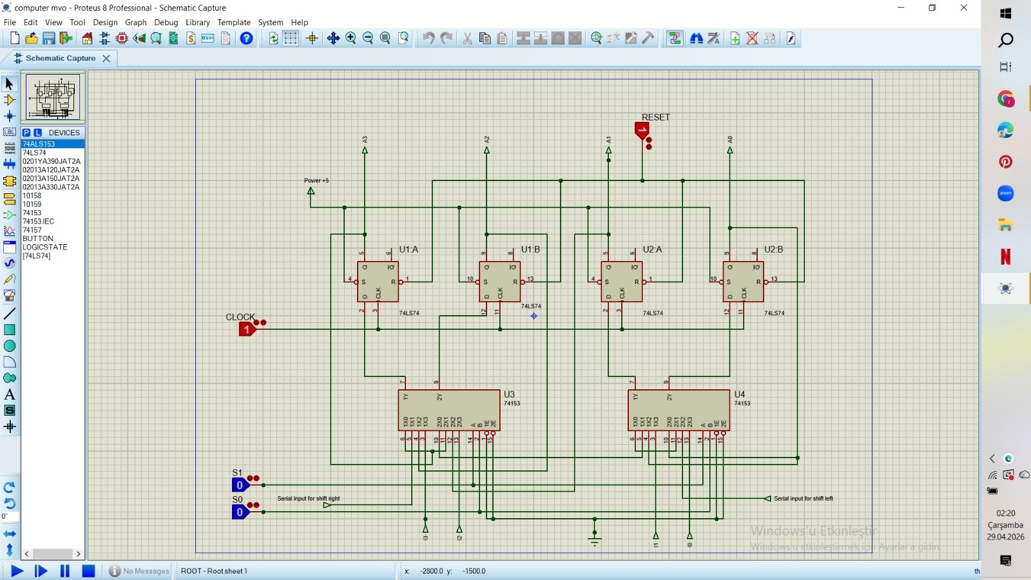

3. VERILOG IMPLEMENTATION

Our design is a 4 bit shift register that uses four flip-flops to store data. A 2 bit input called "process" controls what the system does.
The system is generally synchronous, meaning regular operations (shift, load, hold) happen at the positive edge of the clock signal. However, the reset signal is asynchronous. When reset becomes active (1), the output is cleared immediately without waiting for the clock.

Projecomp.v

module Projecomp(
input clk, // clock
input reset,
input [1:0] process, // Process type: 00:Hold, 01:Right, 10:Left, 11:Load
input [3:0] parallel_in, // Parallel data input
input seri_in, // Bits will enter from the outside while scrolling
output reg [3:0] Q // 4 bit output register
);

always @(posedge clk or posedge reset)
begin
if (reset)
begin
Q <= 4'b0000; // Clear the output the moment reset is 1
end
else
begin
case (process)
2'b00: Q <= Q; // Keep the current data
2'b01: Q <= {seri_in, Q[3:1]}; // Shift right (New data enters from MSB)
2'b10: Q <= {Q[2:0], seri_in}; // Shift left (New data enters from LSB)
2'b11: Q <= parallel_in; //All bits are updated simultaneously with the data received from the outside thanks to the parallel input
default: Q <= Q;
endcase
end
end
endmodule

Projecomptestbench.v

`timescale 1ns/1ps
module Projecomptestbench;
reg clk, reset, seri_in;
reg [1:0] process;
reg [3:0] parallel_in;
wire [3:0] Q;

// We are connecting the circuit to the test
Projecomp shift_register (
.clk(clk),
.reset(reset),
.process(process),
.parallel_in(parallel_in),
.seri_in(seri_in), .Q(Q)
);

always #10 clk = ~clk; // Clock signal changes every 10 ns

initial begin
$dumpfile("ProjectResult.vcd");
$dumpvars(0, Projecomptestbench);

clk = 0;
reset = 1;
process = 0;
parallel_in = 0;
seri_in = 0;

#20 reset = 0; // Wait until 20 ns and exit reset

// Parallel Load: Load the value 1011
process = 2'b11;
parallel_in = 4'b1011;
#10;

// Right Shift
process = 2'b01;
seri_in = 0;
#10; // output 0101

// Left Shift
process = 2'b10;
seri_in = 1;
#10; // output 1011

// Hold Data
process = 2'b00;
#20;

$finish;

end
endmodule
4. TESTBENCH AND SIMULATION

A testbench was developed to verify the correctness of the shift register design. The testbench generates clock signals, applies different input combinations, and observes the output behavior.

The simulation begins with the reset signal activated to initialize the register. Then, different operations are tested sequentially:

1. Parallel Load: A 4 bit value is loaded into the register
2. Right Shift: Bits are shifted to the right with serial input
3. Left Shift: Bits are shifted to the left with serial input
4. Hold: The register value is maintained

The simulation results were observed using GTKWave. The waveform clearly shows that the output changes correctly according to the applied inputs and control signals.

This confirms that the design is functioning as expected.

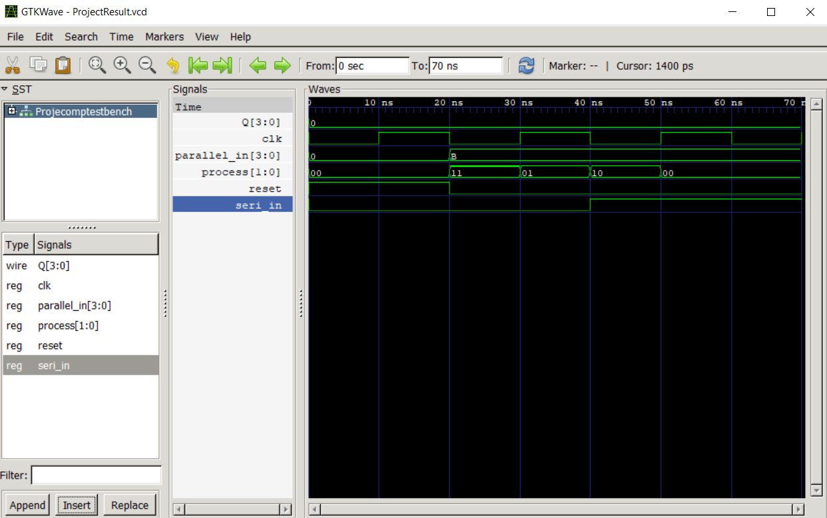

5. DISCUSSION

The designed shift register demonstrates the basic principles of sequential logic circuits. The ability to perform multiple operations within a single module increases its flexibility and usefulness.

One of the important aspects of this design is the combination of serial and parallel data operations. This makes the system suitable for various applications such as data communication and temporary data storage.

The design is scalable, meaning it can be extended to larger bit sizes with minimal modification. This makes it a reusable component in more complex digital systems.

To test the logical correctness of the circuit during the simulation phase, a representative clock period (20ns) was defined on the testbench, and the synchronization of all sequential operations was ensured through this reference.

6. CONCLUSION

In this project, a 4 bit shift register was successfully designed, implemented, and tested using Verilog HDL. The system supports multiple operations and demonstrates reliable performance under different test conditions.

The use of simulation tools such as GTKWave helped verify the correctness of the design. This project provided valuable experience in digital design, hardware description languages, and simulation techniques.

Overall, the project meets all the required specifications and demonstrates a functional and efficient hardware component.

